MS Intouch (Chat Application)

Project Proposal

Session 2023-2027

**A 4th semester Student**

A project submitted in partial fulfillment of the

Term Project

of

BS in Computer Science



Department of Computer Science

Air University Islamabad, Multan Campus

**Project Registration**

|  |  |  |  |  |  |  |  |
| --- | --- | --- | --- | --- | --- | --- | --- |
| Project ID (for office use) | | |  | | | | |
| Type of project | | | [ ] Traditional [ ] Industrial [✓ ] Continuing | | | | |
| Sustainable Development Goals(SDGs) | | | [✓] Good Health and Well-Being [ ] Quality Education  [✓ ] Industry, Innovation, and Infrastructure [ ] Gender Equality  [✓] Decent Work and Economic Growth [ ] Climate Action | | | | |
| Area of specialization | | | Mobile App Development | | | | |
| **Project Group Members** | | | | | | | |
| Sr.# | Reg. # | Student Name | | CGPA | Email ID | Phone # | Signature |
| (i) | 233505 | Syed Muhammad Sarib | | 3.85 | 233505@students.au.edu.pk | 03287887571 |  |
| (ii) | 233553 | Muhammad Maaz | | 3.49 | 233553@students.au.edu.pk | 03168563659 |  |
| **Declaration:**  Group members have cleared all prerequisite course content as per their subject requirements.  For BS(Computer Science)  (CSC241 Object Oriented Programming, CSC291 Software Engineering Concepts, CSC371 Database Systems-I, HUM102 Report Writing Skills) | | | | | | | |

**Project Abstract**

Our chat application integrates AI-powered functionalities while ensuring data security through hybrid encryption techniques. The application will support multiple devices, allowing seamless access across different platforms. Users will have customization options such as theme changing, scheduled messaging, and premium features, including cloud backups and exclusive content. AI-driven enhancements will optimize user experience, offering smart message suggestions, automated replies, and language translation.

**Previous Project Objectives and Features**

* Develop a secure and robust login and signup system.
* Enable users to manage friends and groups efficiently.
* Provide both private and group chat functionalities with advanced filtering options (e.g., by date, text).
* Encrypt all chat data to ensure privacy and confidentiality.
* Implement premium features such as theme customization and chat backups.
* Ensure seamless and real-time communication using socket programming.
* Deliver a smooth, intuitive, and user-friendly interface.

# Introduction

The chat application aims to provide a secure, AI-enhanced messaging platform with advanced encryption techniques. It incorporates a seamless user experience with innovative features such as scheduled messages, multi-language support, and customizable themes.

# Related work

Existing chat applications like **WhatsApp and Telegram** offer encryption and multi-device support but **lack full AI integration and hybrid encryption techniques.** Our application aims to **bridge this gap** by combining **security, personalization, and AI-driven automation**. Additionally, we will take inspiration from **our previous Chat App on console**, developed as part of our **project,** to enhance **data structures, message handling, and overall efficiency** **DSA** in this new implementation.

# Project Rationale

With growing concerns over data privacy, hybrid encryption will enhance security. AI-driven features will make communication smarter and more efficient. This project aligns with current technological trends and offers innovative solutions to modern messaging needs.

## Aims and Objectives

The primary goal is to create an AI-integrated chat application that ensures secure and seamless communication across multiple devices. The main objectives include:

* Develop a secure and robust login and signup system.
* To implement a secure sign-up and login system using Firebase Authentication.
* To allow users to send and accept friend requests for personal conversations.
* To enable group creation, management, and messaging.
* To integrate Cloudinary for efficient media file storage.
* To support password reset and change functionality.
* To display user profiles and chat backups.
* To provide theme customization and smooth animations for a better UI experience.
* Deliver a smooth, intuitive, and user-friendly interface.

## Scope of the Project

The application will be designed for mobile platforms, ensuring secure messaging with encryption, and cross-device compatibility. Premium features will include theme backups and enhanced UI customization.

# Methodology and Architecture

The application will be developed using a modular approach, including:

## 4.1 Technology Stack:

* **Flutter Framework:** Used for building a native-like Android application with a single codebase.
* **Dart Programming Language:** The primary language for Flutter development, selected for its performance and reactive programming features
* **Firebase Backend Services:** Utilized for real-time database (Firestore), user authentication, and other useful functions
* **Cloudinary**: Integrated for efficient media storage and optimization, handling images, videos, and other multimedia content

## 4.2 System Architecture:

* **Type:**  *Modern Mobile Client-Server Architecture*
* **Style:**  *Layered Architecture with Cloud Services*
* **Pattern:** *Publisher-Subscriber (for real-time messaging)*

## 4.3 Development Methodology:

We adopted an **incremental development model** to systematically build our Android chat application by adding functional components in successive, fully-operational increments. This approach allowed us to deliver working software early while progressively enhancing functionality.

# Diagrams

## Flowchart:

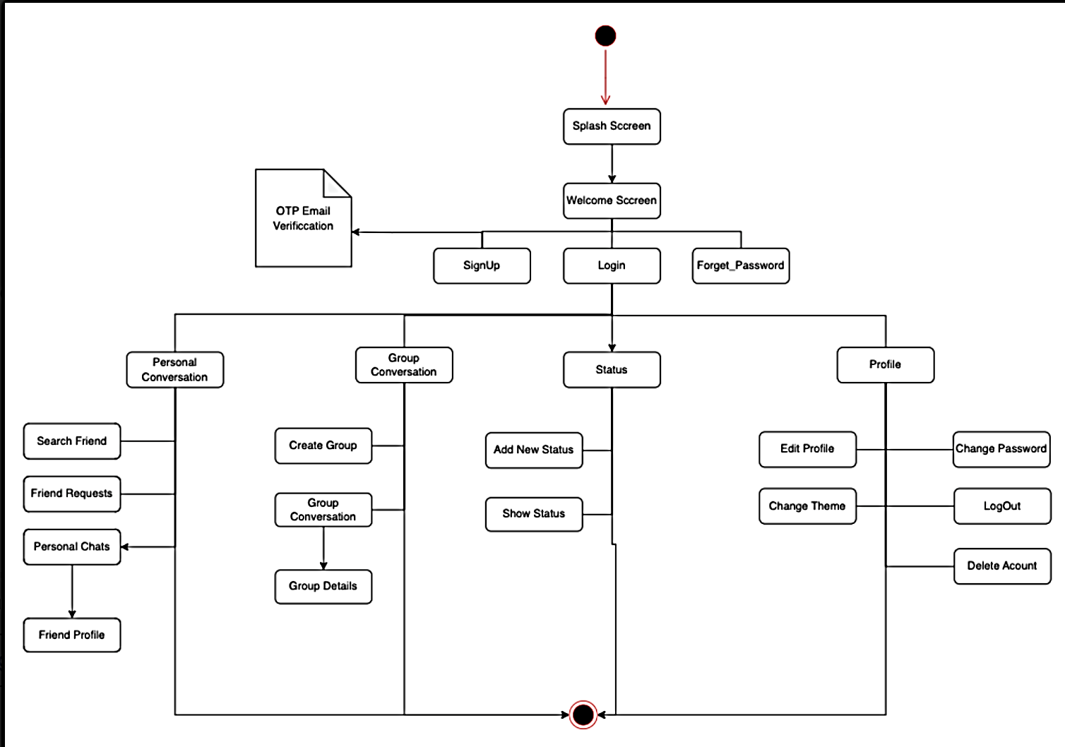

## Database Diagram:

## Data Flow Diagram:

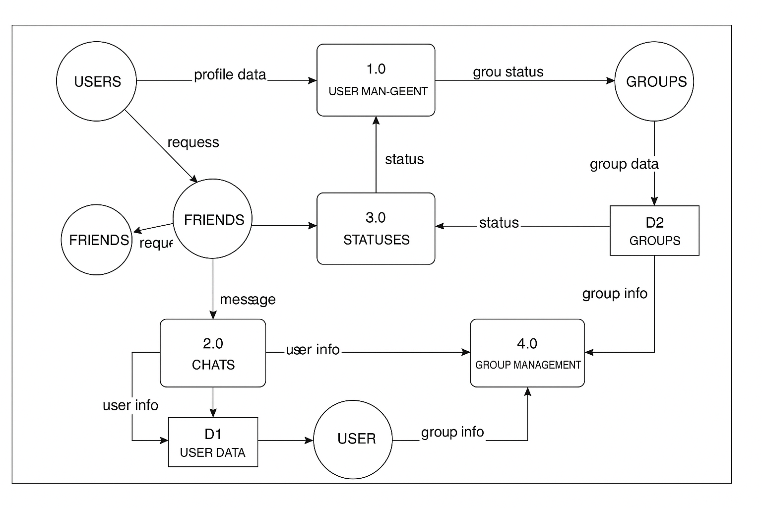

# Individual Tasks

|  |  |  |
| --- | --- | --- |
| **Team Member** | **Activity** | **Tentative Date** |
| Syed Muhammad Sarib | User Research & Requirements | March 20 – March 29 |
|  | UI/UX Design & Prototyping | April 21 – April 25 |
|  | Flutter Setup & Basic UI | April 26 – May 2 |
| Muhammad Maaz | Database Integration & Authentication | May 3 – May 10 |
|  | Core Chat Features Implementation | May 11 – May 20 |
| Syed Muhammad Sarib | Group Conversation | May 21 – May 25 |
| Syed Muhammad Sarib  and Muhammad Maaz | Testing, Debugging & Deployment | May 26 – May 30 |

# Gantt Chart

# Screenshots

## Splash Screen

## Welcome Screen

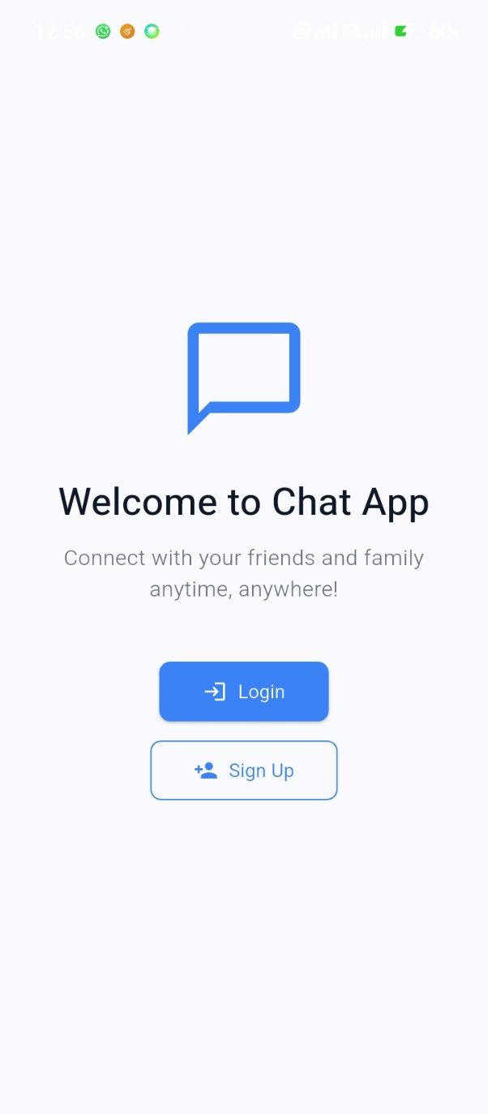

## Signup Screen

## Login Screen

## OTP Verification Screen

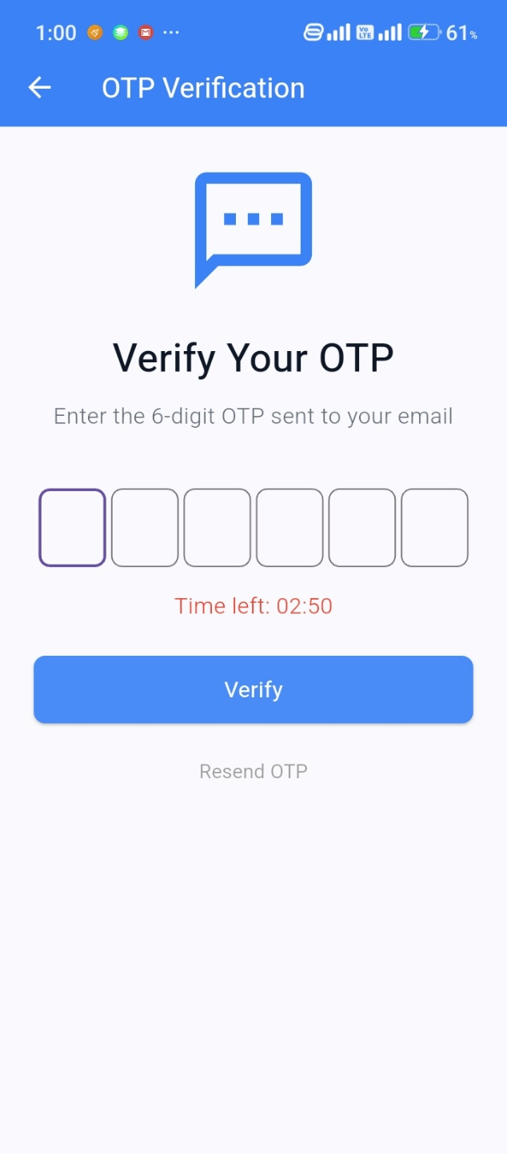

## Friends Screen

## Personal Conversation Screen

## Group Screen

## Group Conversation Screen

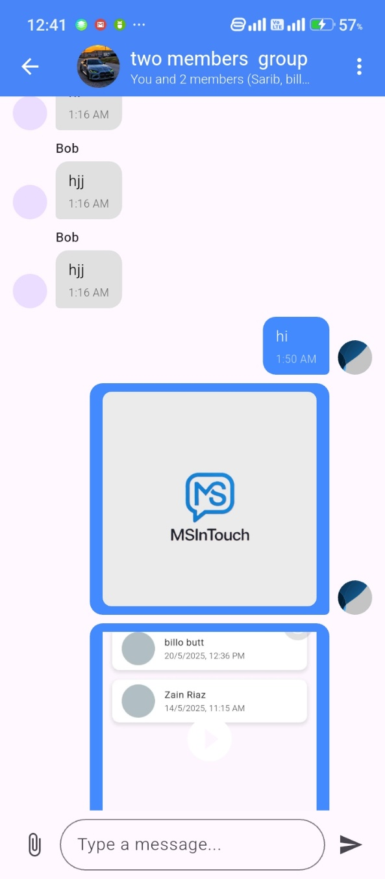

## Create Group Screen

## Status Screen

## Profile Screen

## Edit Profile Screen

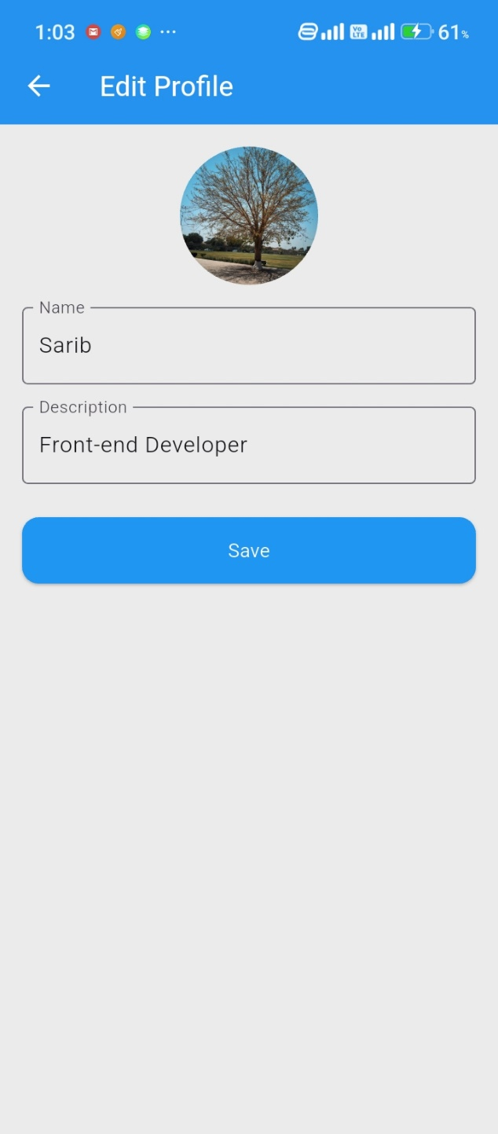

## Get Premium Screen

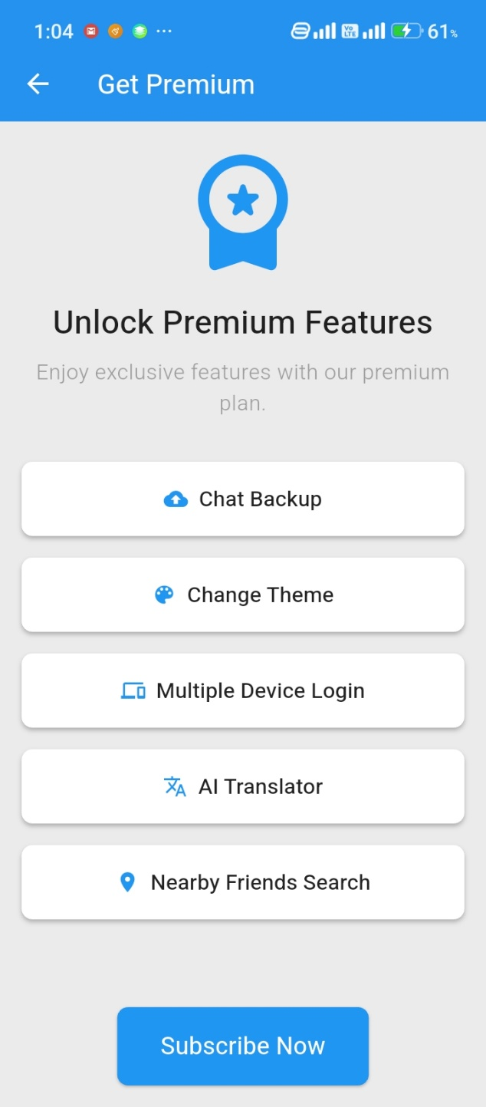

## Change Password Screen

